**Project Design Phase-II**

**Data Flow Diagram & User Stories**

|  |  |
| --- | --- |
| Date | 26th October 2022 |
| Team ID | PNT2022TMID51001 |
| Project Name | Project - Estimate The Crop Yield Using Data Analytics |
| Maximum Marks | 4 Marks |

**Data Flow Diagrams:**

A Data Flow Diagram (DFD) is a traditional visual representation of the information flows within a system. A neat and clear DFD can depict the right amount of the system requirement graphically. It shows how data enters and leaves the system, what changes the information, and where data is stored.

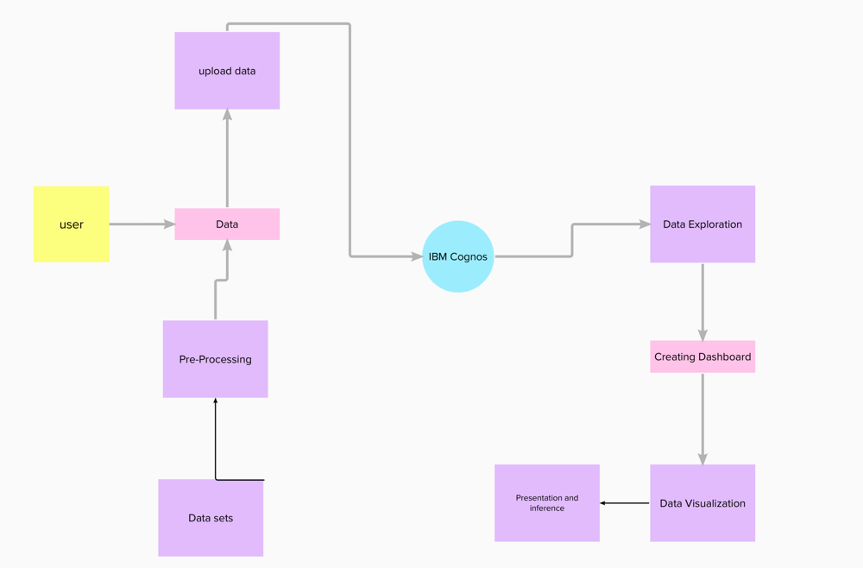

**User Stories**

Use the below template to list all the user stories for the product.

| **User Type** | **Functional Requirement (Epic)** | **User Story Number** | **User Story / Task** | **Acceptance criteria** | **Priority** | **Release** |
| --- | --- | --- | --- | --- | --- | --- |
| Customer | Registration | USN-1 | As a user, I can register in the IBM Cognos by entering a valid email, password, and confirming my password. | I can access my account / dashboard | High | Sprint-1 |
|  |  | USN-2 | As a user, I will receive confirmation email once I have registered | I can receive confirmation email & click confirm | High | Sprint-1 |
|  |  | USN-3 | As a user, I can also register through Gmail | I can receive confirmation email & click confirm | Medium | Sprint-2 |
|  | Login | USN-4 | As a user, I can log into the application by entering email & password | I can get into Cognos analytics | High | Sprint-1 |
|  | Dashboard | USN-5 | As a user , I can view the dashboard and the charts provided there | I can analyse the data of crop yield | High | Sprint-1 |
| Customer (Web user) | Registration | USN-6 | As a user, I can register in the IBM cognos by entering a valid email, password, and confirming my password. | I can access my account / dashboard | High | Sprint-1 |
|  |  | USN-7 | As a user, I will receive confirmation email once I have registered | I can receive confirmation email & click confirm | High | Sprint-1 |
|  |  | USN-8 | As a user, I can also register through Gmail | I can receive confirmation email & click confirm | Medium | Sprint-2 |
|  | Login | USN-9 | As a user, I can log into the application by entering email & password | I can get into cognos analytics | High | Sprint-1 |
|  | Dashboard | USN-10 | As a user , I can create the dashboard and add different visualization charts to it for the dataset. | I can explore, visualize and analyse the data. | High | Sprint-1 |
| Customer Care Executive | Support | USN-11 | As a Executive, Solve queries of the user | Answer to the queries asked by the user | High | Sprint-1 |
| Administrator | Manages site | USN-12 | As a Admin, I can Manages the site | Update the changes | High | Sprint-1 |
|  | Control users | USN-13 | As a admin, I can control the users details and accounts and their access limits | Modify user details, set user limits | High | Sprint-1 |
|  | Database | USN-14 | As a admin, I can Access and monitor the System Database. | Have access to the database | High | Sprint-1 |